**DAILY ONLINE ACTIVITIES SUMMARY**

|  |  |  |  |  |  |
| --- | --- | --- | --- | --- | --- |
| **Date:** | **30-05-2020** | | **Name:** | **Shah Dhruvil Amit** | |
| **Sem & Sec** | **6th - B** | | **USN:** | **4AL17CS083** | |
| **Online Test Summary** | | | | | |
| **Subject** | **PYTHON APPLICATION PROGRAMMING** | | | | |
| **Max. Marks** | **30** | **Score** | | **18** | |
| **Certification Course Summary** | | | | | |
| **Course** | **Build an e-commerce with ReactJS** | | | | |
| **Certificate Provider** | **learncodeonline** | **Duration** | | | **As per progress(no duration specified)** |
| **Coding Challenges** | | | | | |
|  | | | | | |
| **Status: executed** | | | | | |
| **Uploaded the report in GitHub** | | **Yes** | | | |
| **If yes Repository name** | | <https://github.com/DhruvilShah99/Daily-Updates> | | | |
| **Uploaded the report in slack** | | **Yes** | | | |

Online Test Details:

Second I A of PAP

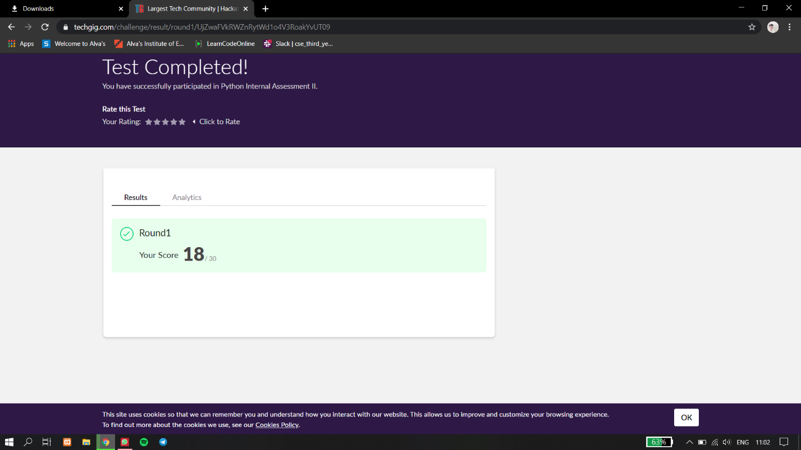

Certification Course Details:

Report



In today’s session for online certification I have learned about using environment variables in react as well as applying graphql query on contentful where the database is stored.

Coding Challenges Details:

The below GitHub link for details

<https://github.com/DhruvilShah99/Daily-Updates>

P-1

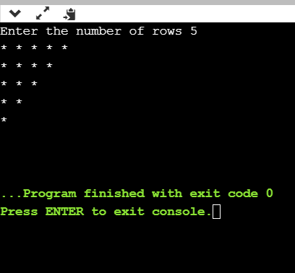

Python program to read a number and print the pattern

P-2

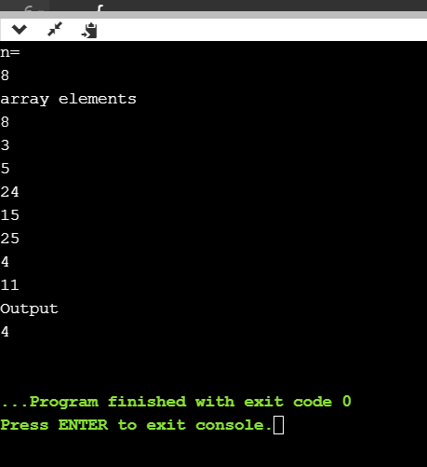

Java program to Count number of trailing zeros in product of array